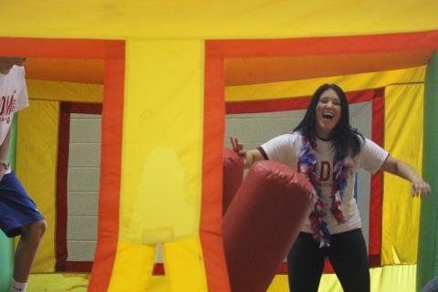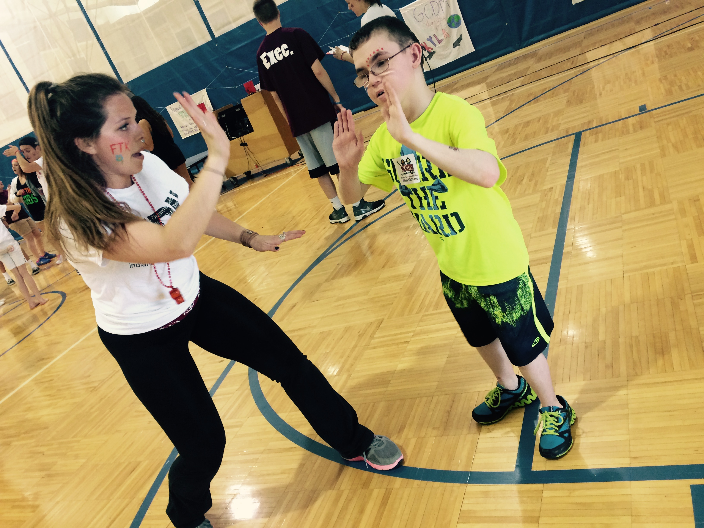

All Proceeds Go To…

**April 9th, 2016 GCHS Field House**

**2:00-8:00pm**

##### Come join us for:

##### Obstacle course bounce houses

##### Car Smash (possibly)

##### Pizza/Cotton Candy

##### Snowie

##### Hair Chop

##### Cheer Performance

##### Face-painting

##### Riley kids

##### DODGEBALL TOURNEY

Making Miracles Happen

Riley Hospital for Children

##### Come join us during our second annual Riley Dance Marathon. At Greenfield Central High School on April 9th,2016 from 2-8pm!

### Greenfield Central

### Dance Marathon

GCDM 16”

FTK

GCDM